TRANSDAIRY in Tunisia highlights the role of ICT as a lever of development of the dairy value chain

The Mediterranean exhibition of animal production and agricultural products in Tunisia "PAMED" 2022 is a professional exhibition that gathers most of dairy value chain actors in Tunisia with:

* +150 exhibitors
* + 15 participating countries
* + 8000 visitors

The ICT Living Lab of APII has participated in this exhibition in 2021.

The fair was the opportunity to:

* Meet DVC stakeholders and start-ups working on the agriculture field.
* Disseminate TRANSDAIRY project, its goals and its activities
* Invite people to visit and subscribe in the collaborative platform of the project
* Invite people to answer the questionnaire of offer and demand of TIC in the dairy value chain,
* Meet start-ups and TIC experts that could participate to the project.

The ICT Living Lab has also participated as a jury member in the PAMED- INNOVATION, which is a competition, dedicated to start-ups working on the agriculture field.

[Tunisie: Participation de TRANSDAIRY au Salon méditerranéen de la production animale et des produits agricoles | ENI CBC Med](https://www.enicbcmed.eu/tunisie-participation-de-transdairy-au-salon-mediterraneen-de-la-production-animale-et-des-produits)

That’s why, the ICT living lab of APII decided to organize the Dairy Innovation Days - TRANSDAIRY cross-border ICT brokerage and matchmaking event, within this exhibition from 14th to 17th of June 2022 in hammamet- Tunisia as a special edition of PAMED INNOVATION.

The call for start-ups to participate in this event was published on the APII website, social media of TRANSDAIRY project and the ENICBCMED website:

[CROSS-BORDER.pdf (tunisieindustrie.nat.tn)](http://www.tunisieindustrie.nat.tn/fr/download/news/2022/CROSS-BORDER.pdf)

[Join TRANSDAIRY in the Cross-Border Brokerage and Matchmaking Event in ICT for the Dairy Value Chain in Tunisia | ENI CBC Med](https://www.enicbcmed.eu/join-transdairy-cross-border-brokerage-and-matchmaking-event-ict-dairy-value-chain-tunisia)

<https://www.facebook.com/Transdairyproject/photos/a.110846744267009/392841416067539/>

30 start-ups applied and 26 were selected based on eligibility and selection criteria.

Here is the detailed information about the participants:

|  |  |  |  |  |
| --- | --- | --- | --- | --- |
| **Start-up Name** | **Logo** | **CEO** | **Age** | **Brief description of the prject idea** |
| Vagrok |  | FLIS Achraf | 40 | An IoT system consisting of a collar to detect the heat and health of the animal permanently and a milk analyzer that measures milk quality and composition. An algorithm and AI model to warn the user in case of emergency will process this data collected in the server. |
| Elastic-Solutions |  | KOUKA Abdelmonam | 39 | A platform for early detection of diseases of cattle troops based on behavioral analysis of video streaming |
| Scientia Tec |  | BOUAKROUCHA Ahmed | 23 | A platform connectifs farmers to milk collectors and milk industries |
| TIC AGRI TECHNOLOGY |  | ABDELKADER Aya | 23 | A smart container capable of storing raw milk, doing the analyses continuously and sending the data to the server.  The smart container helps to secure and optimize the collection of milk from the farm to the processing plants |
| SKYTECH TN |  | HAFIEN Chedhli | 32 | A flying bio-robot with flapping wings inspired by an eagle equipped with GPS, Gyroscope, Thermal Sensor, Humidity Sensor, and Multi-Spectral Camera. This robot is used to scare birds to protect agricultural products on farms and especially fodder |
| I-CowCare |  | HARBAOUI Imen | 39 | IoT platforms that can integrate a set of sensors useful for monitoring cow health indicators + a mobile/desktop application that provides a dashboard to the farmer. This dashboard will aim to allow the breeder to visualize the evolution of indicators of interest and assist in the prediction of periods of heat, health problems and poor nutrition. |
| ElFerma |  | Oussama nidhal | 22 | An online marketplace specialized in the dairy products. The name of our platform will be *elFerma Lait+' It will facilitates the linking between local producers with customers (B2C) and exporting or aggregated companies (B2B). |
| Elvache |  | BOUAKROUCHA Yasmine | 23 | A robot that allows milking and controlling each cow on a daily basis 100% automatic: quantity of milk per milking, conductivity for mastitis control, activity for heat monitoring, quantity of concentrates consumed per milking… |
| SL-Cow |  | ZANNED SAMEH | 40 | An intelligent system (based on IoT) that describes a synthesis of the action plan of environmental factors to improve the well-being of dairy cows at all times |
| GOVINDA |  | OUESLATI ONS | 20 | A multi-sensor system that allows optimizing milking quality and quantity |
| Vashista |  | OUDERNI Houssem | 20 | A system that facilitates for farmers the detection of heat periods and sends alerts. |
| AGRI NEXT WAVE |  | BETTOUMI Yathreb | 26 | An IoT system for the milk quality control +a digital farm management platform |
| AGRITRONIC |  | ALOUI Mohamed Taieb | 26 | A sensor that can monitor PH, conductivity, soil moisture content as well as several parameters. the data are then processed to allow a better control of irrigation and agriculture |
| GUSTO PRIMAVERA |  | GUIZANI Nour | 27 | Local cheese producer |
| dB Sense |  | MECHERGUI Nader | 45 | A solution to reduce the noise of milking machines and improve the milking process |
| JAIDEN Mariem | 62 |
| Smart Farm System |  | KHLIFI Jihen | 23 | A system that comes to control and command the resources necessary to ensure a well-balanced and secure environment according to all animal entities and other living species.  The system can be ordered remotely without any need for intervention of a workforce. |
| Smart Engineering Solutions |  | AMDOUNI Mayssa et hamza HAMDI | 25 | A smart solution for barn cleaning that allows to have better environment for cows and then better performance of milking |
| eXDairy |  | BEN ISSA Takoua | 30 | Creating of multisensory virtual environments to improve cow’s lifestyle and behavior in order to enhance their productivity using Extended Reality technologies |
| Rissala kids farm |  | MEFTEH Imen | 40 | A platform and mobile application that links educational and zoo-therapeutic reception providers (farms) with their target customers (kindergartens, primary schools, associations, families, etc.) and a market place allowing them to present their products and services |
| Aggribrand |  | BOUGUERRA Sawssen | 26 | A marketplace for commercialization of natural local authentic products and 100% eco-responsible |
| MooMe |  | BEN ACHBALLAH Ahmed | 35 | - Detection Collar heat and illness  - Management platform for livestock managers |
| Lait espoir |  | KHALFAOUI Haifa | 35 | A milk farm in Jendouba (in north west Tunisia).  Adopting a scientific approach discarding conventional ways in cattle farming.  Good practices adapted to the cow’s potential and environment, better health for the herd and more profitability for the farmer. |
| NANOLEL |  | KHLIFI Akila | 40 | ESIM CANDIDATES |
| BIOSENSOR |  | GHRAM Imen | 40 |
| MATMOUR | C:\Users\Bizerte\Desktop\Capture d’écran 2022-03-13 234655.jpg | BRIKI Hajer | 30 | Digital platform for dairy value chain actors offering services like: information, training, good practices, coaching, products and machinery selling |
| IRA MEDENINE | Afficher l’image source | Chaima | 23 | A system that improves camel milking |

**Agenda of the event**

**14th of June 2022**

|  |  |  |  |  |  |  |  |  |  |  |  |  |  |  |  |  |  |  |  |  |  |
| --- | --- | --- | --- | --- | --- | --- | --- | --- | --- | --- | --- | --- | --- | --- | --- | --- | --- | --- | --- | --- | --- |
| 10 :00-12 :00 | | | | | | | | **Opening ceremony**  • Omar BOUZOUADA, General Manager of APII | | | | | | | | | | | | | |
| 12 :00-13 :00 | | | | | | | | **Presentation of the TRANSDAIRY project**  • Ali GOMRI & Manel ROUIS : project coordinators | | | | | | | | | | | | | |
| 13 :00-14 :00 | | | | | | | | **Lunch** | | | | | | | | | | | | | |
| 14:00-15:00 | | | | | | | | **Panel 1: GLOBALET NET**  **IOT, Al and digital platforms in Tunisia** | | | | | | | | | | | | | |
| •Nabil ZAKRAOUI, Globalnet Presales Director | | | | | | | | | | | | | |
| **Presentation of the 1st IOT network in Tunisia by GLOBALNET**  • ANAS OUALI, Business Development Manager of 3S group | | | | | | | | | | | | | |
| 15:00-18:00 | | | | | | | | **Panel 2: IOT, Al and BLOCKCHAIN**  **Smart IOT for Agritech**: | | | | | | | | | | | | | |
| • Pr. Besma KORCHANI – ISIMED | | | | | | | | | | | | | |
| **Al and Agriculture 4.0:** | | | | | | | | | | | | | |
| • Pr. Somaya ABIDI - ENI CARTHAGE | | | | | | | | | | | | | |
| **Blockchain technology** | | | | | | | | | | | | | |
| • Pr. Kaouther SETTHOM - INNOV COM LAB SUPCOM | | | | | | | | | | | | | |
|  | | |  | | |  | | | |  | | | **15th June 2022** | | |  | | |  | | | |
| 10:00-12:30 | | | | | | **Panel1**: **Support institutions and mechanisms for financing innovation** | | | | | | | | | | | | | | | | |
| **National Network of Business Incubators of "APII"** | | | | | | | | | | | | | | | | |
| * Maher AGERBI- Director of Business Creation and Support Center of APIl | | | | | | | | | | | | | | | | |
| **National Network of Business Incubators of "APIA"** | | | | | | | | | | | | | | | | |
| * Senda HAFSI - Expert in Agricultural Entrepreneurship in APIA | | | | | | | | | | | | | | | | |
| **Agriculture and Agritech Financing programs**  **END TAMWEEL**   * Kheireddine KAAHIA - Responsible for agricultural and environmental strategy in Enda TAMWEEL   **ADVANS**   * Imen MECHERGUI - Business Development manager in ADVANS   **Role of incubators and accelerators**   * Ryadh BOUSLAMA - CEO LEVEL1   Malek CHANNOUFI - CEO STARTUP GATEX | | | | | | | | | | | | | | | | |
| 12:30- 13:00 | | | | | | **Panel 2: Contribution of Higher School of Food Industries of Tunis « ESIAT » in the DAIRY Value Chain**  • Prof. Mouna BOULAARES and Prof. Faten KACHOURI - ESIAT | | | | | | | | | | | | | | | | |
| 13:00-13:30 | | | | | | **Panel 3: Camel milk in Tunisia challenges and opportunities**  • Prof. Touhami KHORCHANI - Arid Regions Institute “IRA MEDNINE” | | | | | | | | | | | | | | | | |
| 13:30-14:30 | | | | | | **Lunch** | | | | | | | | | | | | | | | | |
| 14:30-15:30 | | | | | | **Demonstration of AGRITECH solutions (02 start-ups)**  - ELASTIC SOLUTIONS  - IBIOTECH | | | | | | | | | | | | | | | | |
| 15:30-18:00 | | | | | | **Matchmaking sessions** | | | | | | | | | | | | | | | | |
|  | | | |  | | | |  | | | **16th June 2022** | | |  | | |  | | |  | | |
| 10:00-13:00 | | | | | | | | **Hackathon on IOT for the Dairy Value Chain**  (students from ISTIC and FST) | | | | | | | | | | | | | | |
| 13:00-14:00 | | | | | | | | **Lunch** | | | | | | | | | | | | | | |
| 14:00-00:00 | | | | | | | | **Hackathon on IOT for the Dairy Value Chain**  (students from ISTIC and FST) | | | | | | | | | | | | | | |
|  | |  | | |  | | | |  | | | **17th June 2022** | | |  | | |  | | | |
| 00:00-9:00 | | | | | **Hackathon on IOT for the Dairy Value Chain**  (students from ISTIC and FST) | | | | | | | | | | | | | | | | |
| 9:00 – 11:00 | | | | | **Pitching of Hackathon groups** | | | | | | | | | | | | | | | | |
| **Result Announcement winners awarding** | | | | | | | | | | | | | | | | | | | | | |
| 11:00-12:00 | | | | | **Panel 1:**  **Formulation of phytogenic additives for animal husbandry**  • Pr Moufida SAIDANI TOUNSI - Biotechnology Center of Technopole Borj Cedria  **Treatment and recovery of dairy waste**  • Dr. Mariem KASMI - Biotechnology Center of Technopole Borj Cedria | | | | | | | | | | | | | | | | |
| 12:00-13:00 | | | | | **Panel 2:**  **AGRITECH and cooperation programs in Tunisia**  • Wahid MAROUAN – GIZ - IAAA project   * Nifel MAHJOUB – CAWTAR - INNOVAGROWOMED project | | | | | | | | | | | | | | | | |
| 13:00-14:00 | | | | | **Lunch** | | | | | | | | | | | | | | | | |
| 14:00-17:30 | | | | | **Start-up Pitching sessions** | | | | | | | | | | | | | | | | |
| **Closing ceremony and winners awarding** | | | | | | | | | | | | | | | | | | | | | |

**Guests and participants**

The hall dedicated for dairy innovation days and conceived by APII gathered in a start-up village over 25 start-ups working on ICT dedicated for dairy value chain.

Each start-up has its own booth with its logo, which allowed them to present their projects and services for dairy actors, investors, business incubators and financing institutions.

The event was also an opportunity for start-ups to know each other, discover similar services afforded by some of them and complementarity between some of them. That is why many partnerships were created thanks to this event.

The dairy innovation days’ hall also welcomed support institutions and dairy value chain actors:

- Business incubators:

* National Network of Business Incubators “**RNPE**” of APII (26 business incubators in all Tunisia presenting coaching and assistance services, trainings and business hosting for entrepreneurs in industry and related services),
* National Network of Business Incubators “**RNPEA”** of "APIA" (7 business incubators in all Tunisia presenting coaching and assistance services, trainings and business hosting for entrepreneurs in agriculture and related services),
* **Startup Gatex** and **Level 1** (private incubators and accelerators)

- Financing institutions: **ENDA TAMWEEL**, **ADVANS** (2 of most popular micro finance institutions in Tunisia)

- Dairy value chain actors: **DAIRY CLUB** (association), **NATILAIT** (one of the biggest dairy industry in Tunisia)

DAIRY CLUB Tunisia is non-profit association, whose objectives are:

* The development of the techniques of breeding of the dairy cows
* The establishment of links of cooperation and exchange of experiences between the breeders and the concerned structures and institutions
* The establishment of relations of twinning and cooperation with foreign professional structures.

- ICT experts: Higher Institute of Information and Communication Technologies **“ISTIC**” (TRANSDAIRY associated partner), **GLOBAL NET** (founder of **1st IOT network in Tunisia)**

In fact, Leader in Enterprise Internet services, GLOBAL NET Business has strengthened its position by becoming the first MSP (Managed Services Provider) and by launching the first national IoT network in Tunisia, through the parent company 3S, Standard Sharing Software in 2019.

The objectives of the IoT network are:

- Respond to different use cases requiring the transmission of small quantities of information at long range with cost and energy consumption constraints;

- Support companies and start-ups in their IoT projects: from connectivity to transport, while guaranteeing a level of security that complies with current norms and standards.

This strategy, based on the open LoRaWAN technology, allows to respond to the specificities of IoT projects in emerging economies, while guaranteeing interoperability between all the players in the value chain: application publishers, connected object manufacturers, equipment manufacturers, service providers, etc.

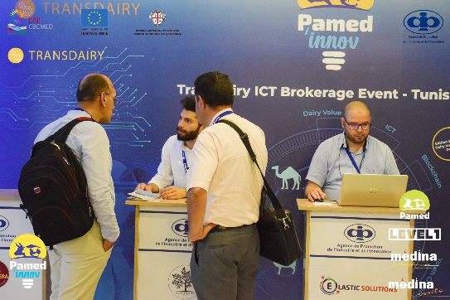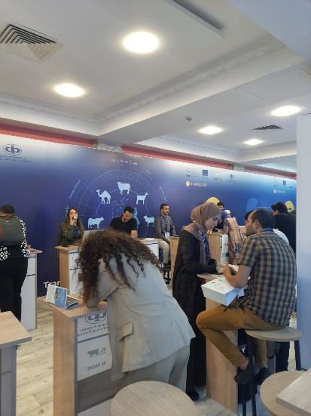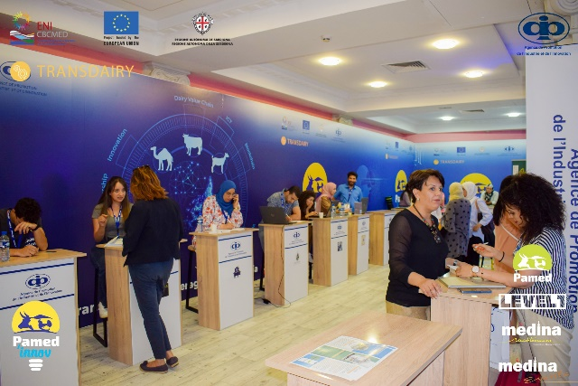Globalnet is committed to supporting start-ups throughout their solution development process. How? By providing them with its know-how, its IoT network as well as specific hardware free of charge, which will be used for the prototyping of their application/solution such as Arduino boards, sensors and other electronic components.

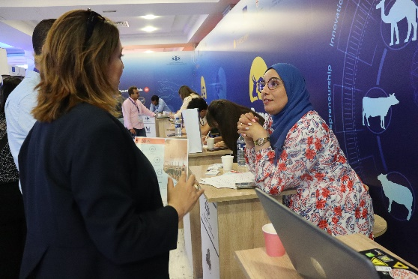.

**Matchmaking:**

Every start-up had the opportunity to conduct at least 5 B2B meetings.

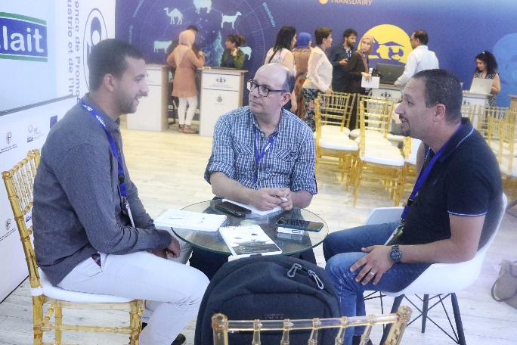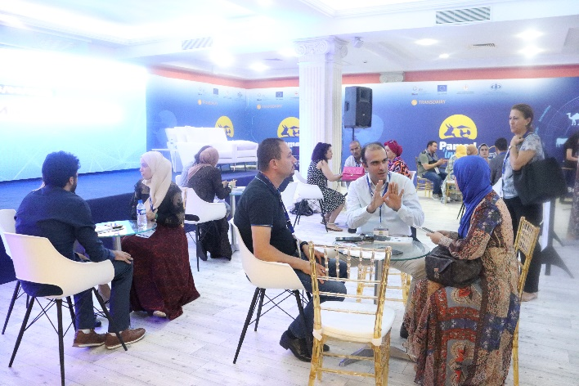

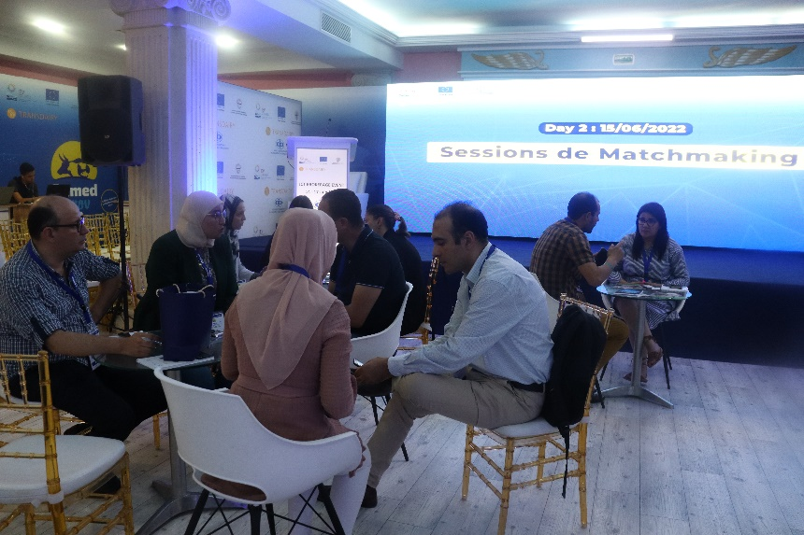

**Panels and discussions**

During the ICT brokerage event, many panels and discussions were conducted about

- The TRANSDAIRY project and its role in promotion of key enabling technologies for the dairy value chain (activities, objectives, vouchers, grants, etc.)

- ICT (IoT, AI, blockchain, digital platforms, etc…)

- Financing and support programs for innovation and agritech

- Camil milk in Tunisia – opportunities and issues

- Dairy value chain: main researches

- Other international cooperation projects working on AGRITECH or the Dairy Value Chain in Tunisia

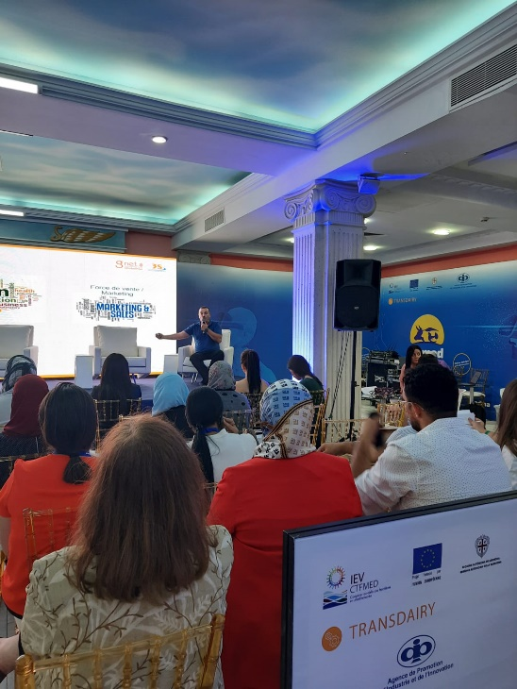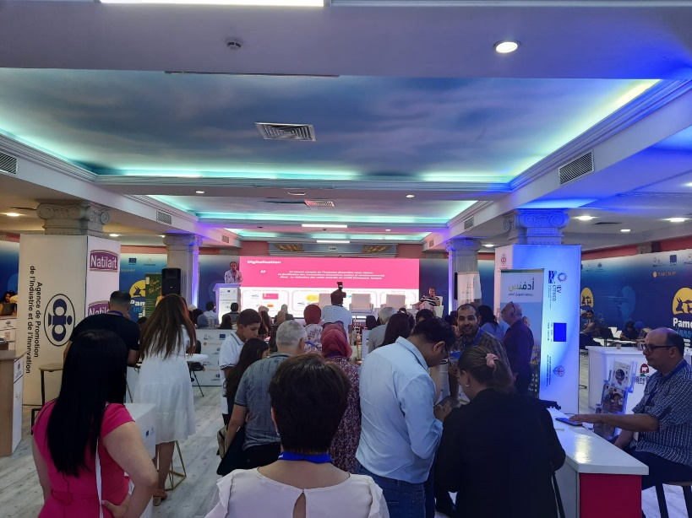

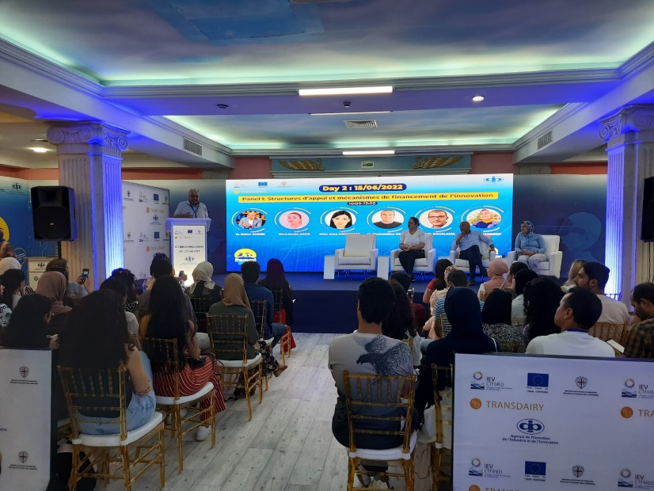

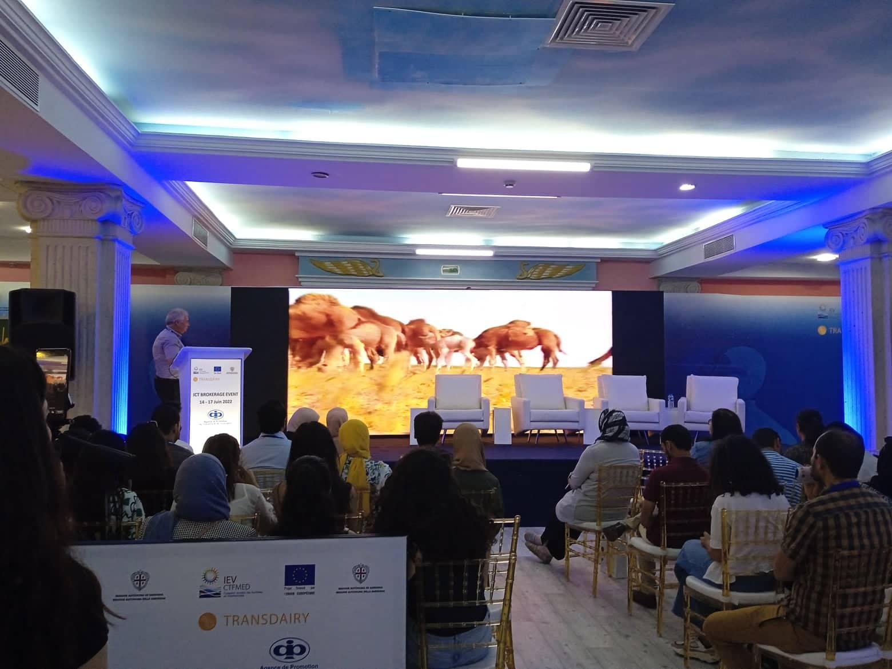

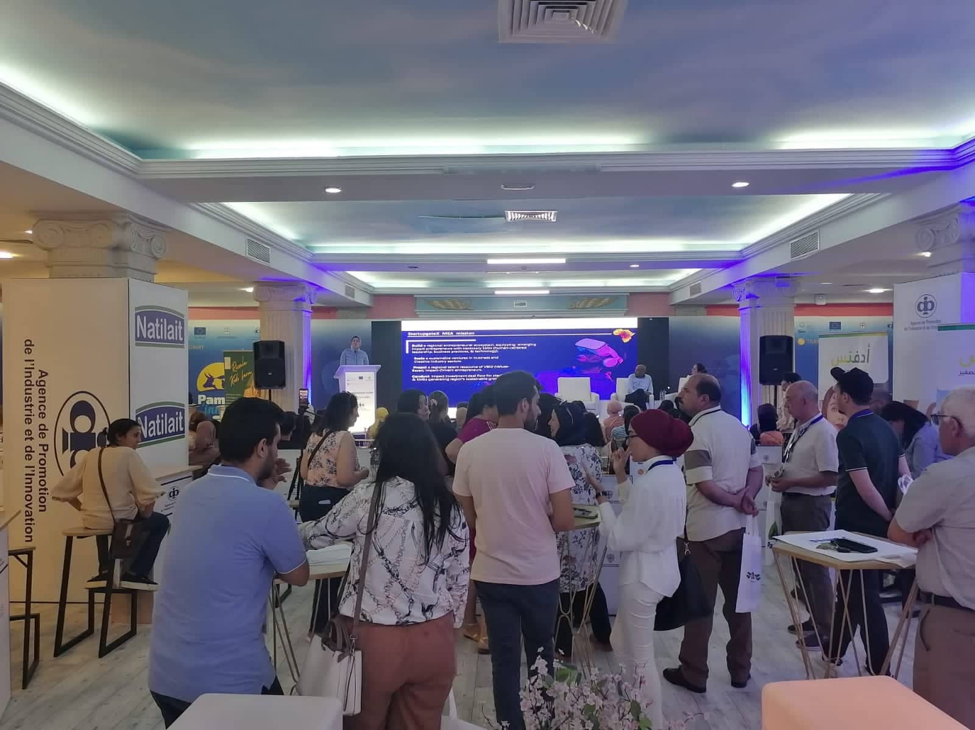

**IoT Hackathon**

During the ICT brokerage and matchmaking A Hackathon on IoT applied on the dairy value chain was organized for ISTIC - Higher Institute of Information and Communication Technologies and FST – Sciences University of Tunis students (25 students).

The call was launched for participants from ISTIC and FST through this link:

[inscription pour participer au ''Hackathon'' (google.com)](https://docs.google.com/forms/d/e/1FAIpQLSeXBJbMR8XzkLRzZqKm8QSYDQao29Pe3EZixk3lyvzC-Gd5ww/viewform?vc=0&c=0&w=1&flr=0)

And 74 students applied to participate.

The Universities’ professors selected 25 students and priority was given to those in the final year.

A guide was developed with conditions, evaluation criteria and a scoring grid.

During 24 hours, students were divided to 6 teams and have worked on IoT solutions for the Dairy Value Chain and the results were just amazing. Brilliant ideas were presented to the jury members and 2 teams were rewarded.

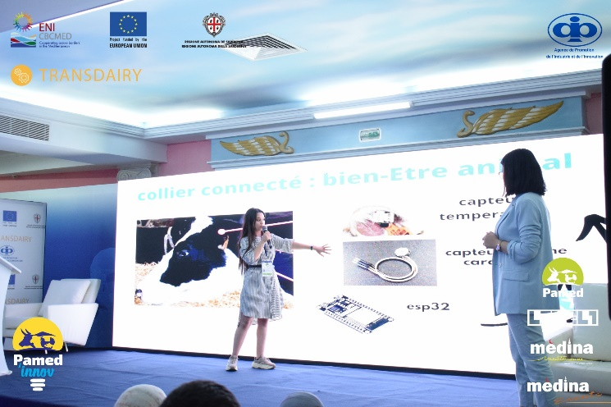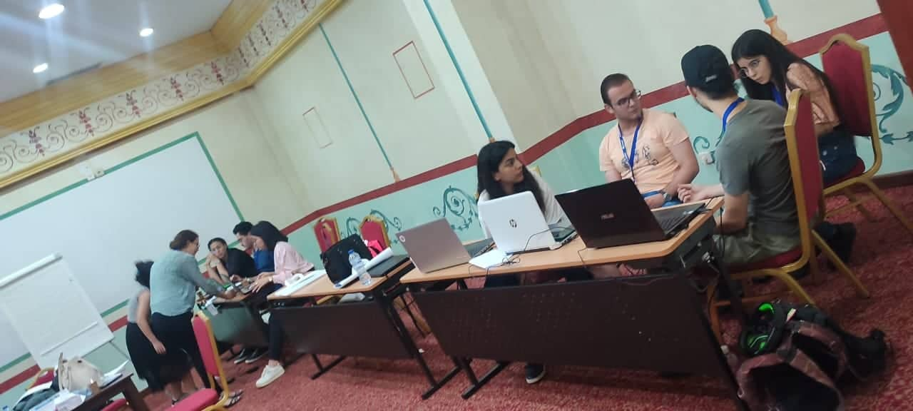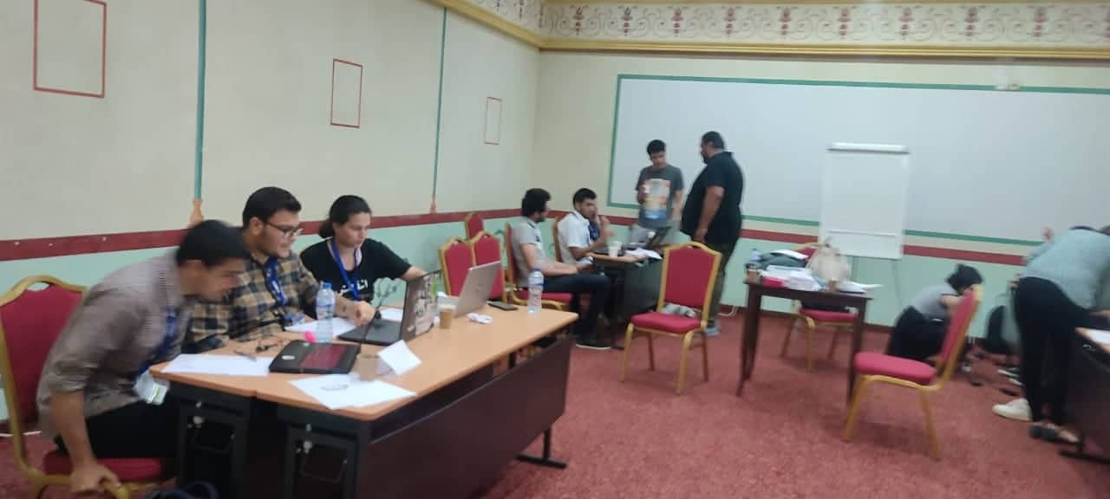Prizes were offered by GLOBALNET Tunisia and STARTUP GATEX.

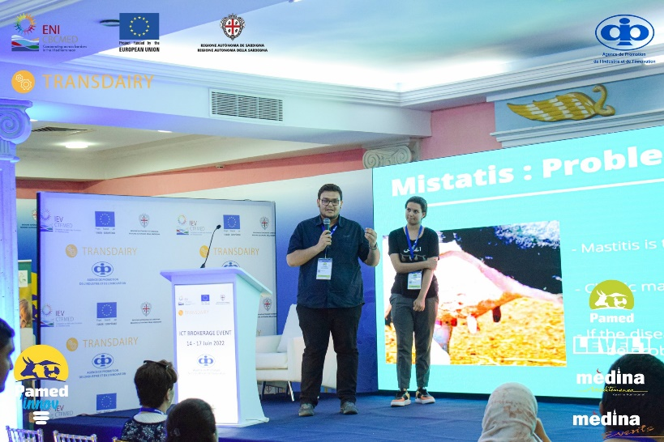

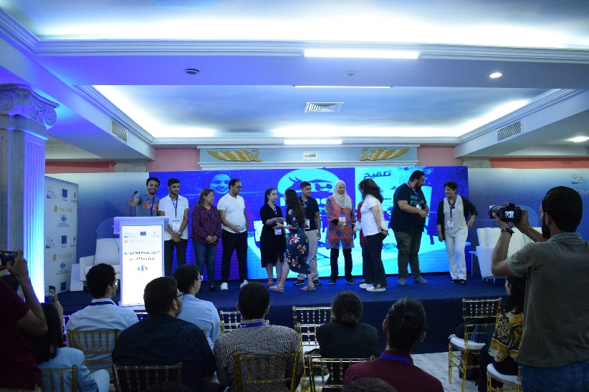

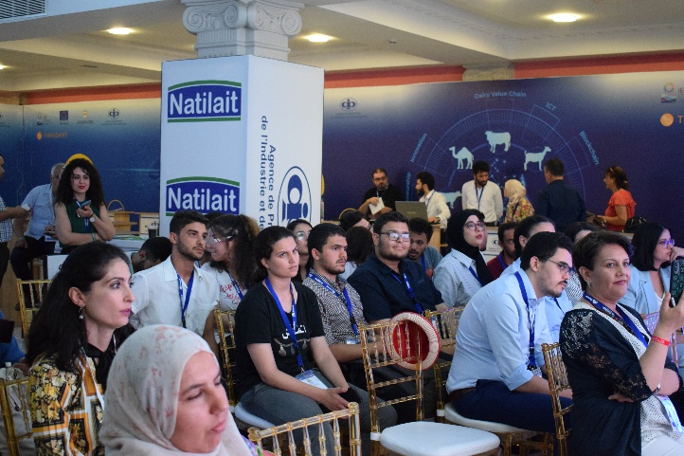

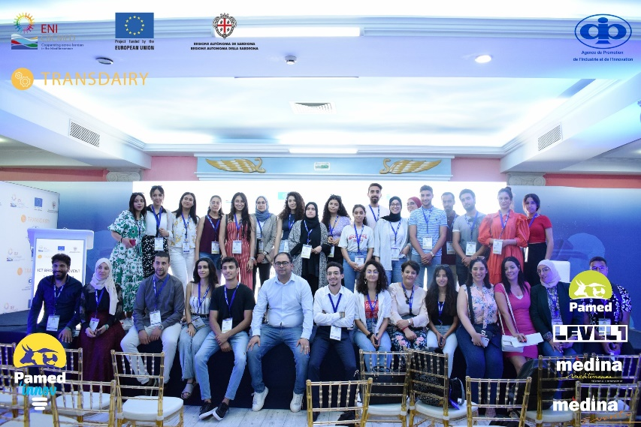

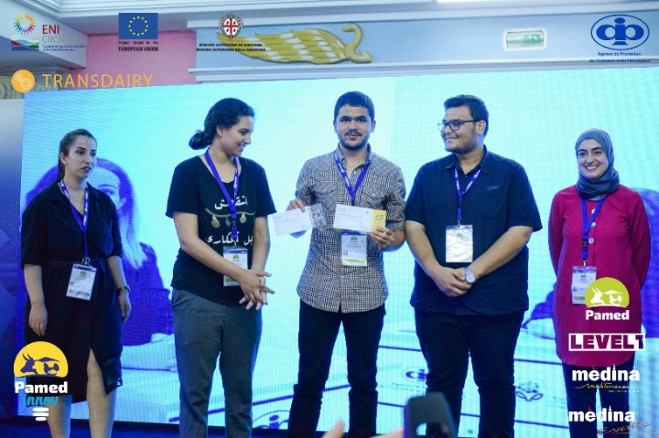

**Start-ups Pitching Sessions**

At the end of the event, 14 start-ups were selected to pitch in front of a specialized jury composed of dairy experts, ICT experts, entrepreneurship experts and incubators and the exhibition visitors.

Here is the [evaluation grid](calls%20TRANSDAIRY%20MAI2022/Brokerage%20Event/Photos%20article%20ICT%20Brokerage%20Event/Pitching/Pitching%20evaluation%20grid.xlsx) used.

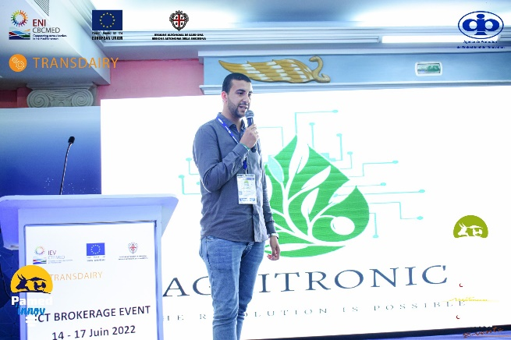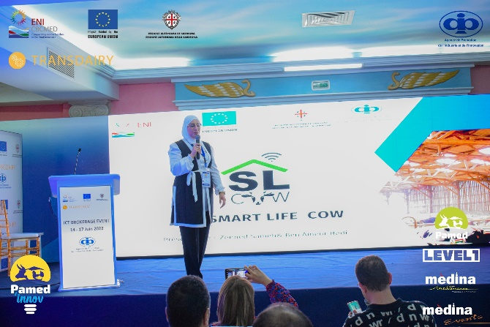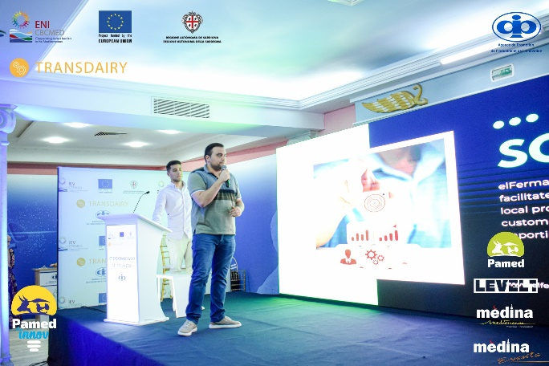

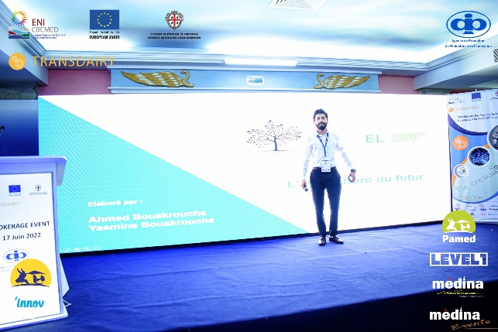

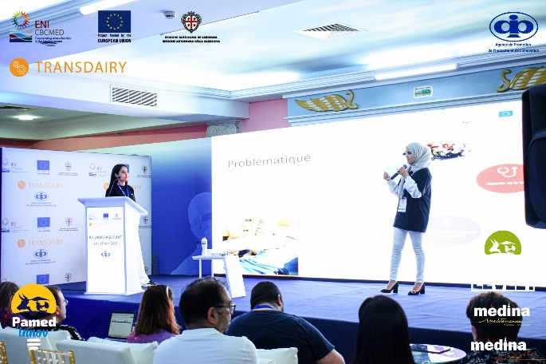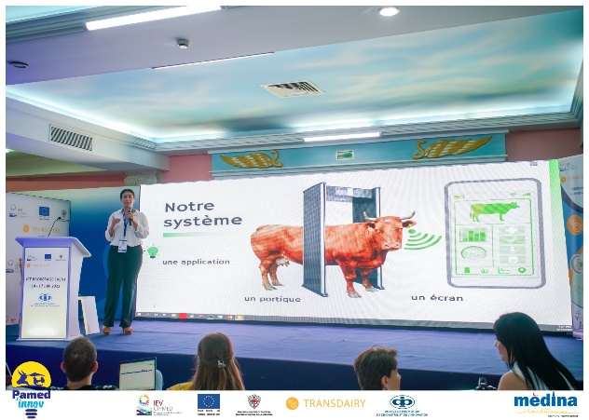

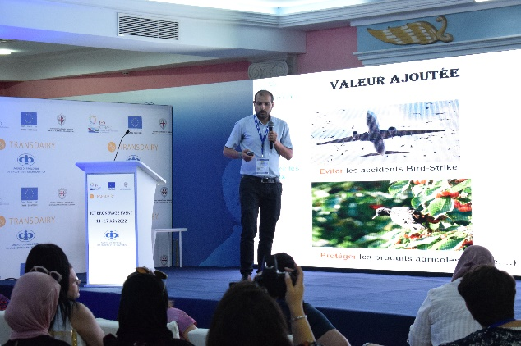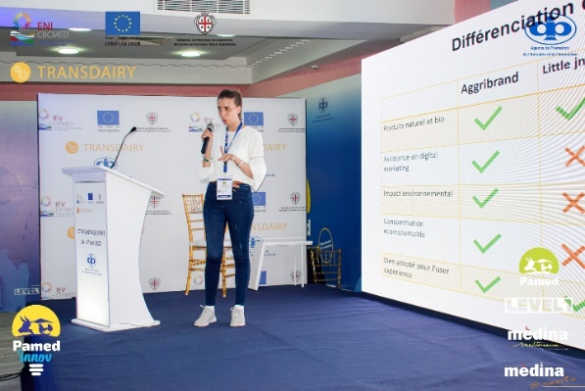

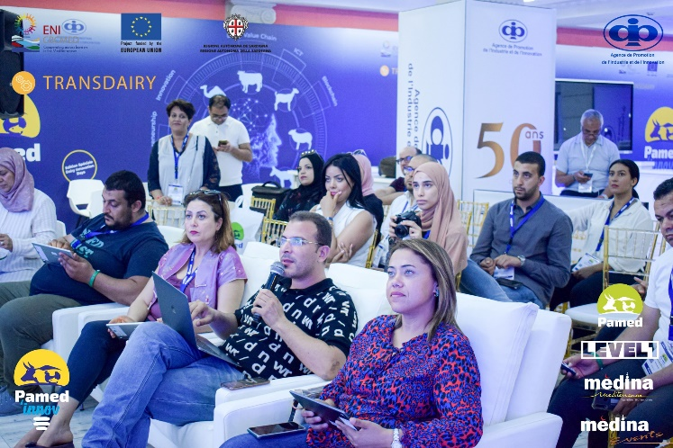

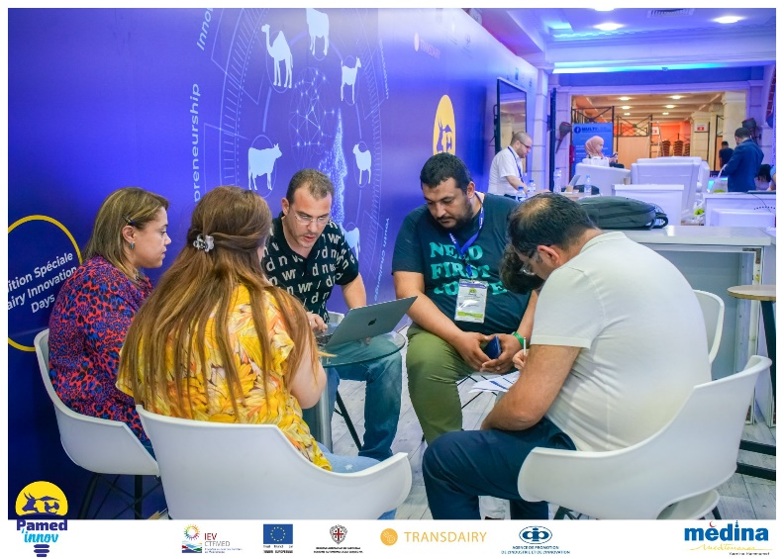

2 start-ups were awarded and the prizes were offered by LEVEL1 (a business incubator).

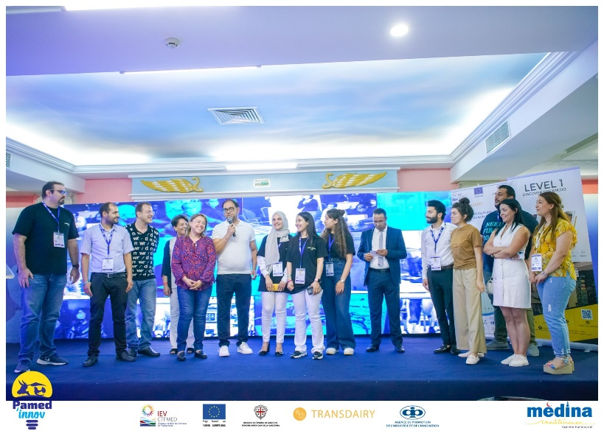

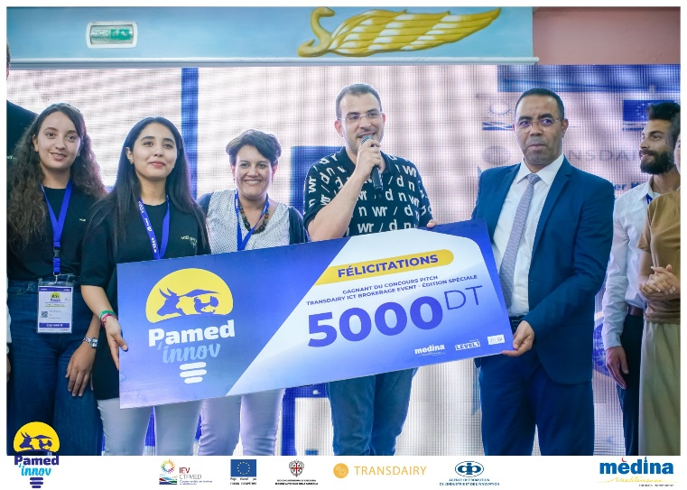

**Main outputs of the Tunisian ICT brokerage event**

- Promotion of ICT as a key enabling technology for the dairy value chain ([over 500 participant](calls%20TRANSDAIRY%20MAI2022/Brokerage%20Event/Photos%20article%20ICT%20Brokerage%20Event/participation%20sheets.pdf))

- Fruitful matchmaking and partnerships creation between start-ups, start-ups and the dairy actors, start-ups and financing institutions and start-ups and incubators

- Creation of synergy between TRANSDAIRY project and other international cooperation projects working on AGRITECH or the Dairy Value Chain

**Social Media Communication**

[**https://www.facebook.com/events20/photos/a.188859351752849/1032709924034450/**](https://www.facebook.com/events20/photos/a.188859351752849/1032709924034450/)

[**https://www.facebook.com/events20/posts/pfbid02jyUg2j7PhMMiL6XVE6td7LvqmvUM39MC8enQJ2q18e7NAUXxb4RgRQXtgrjzLN5yl**](https://www.facebook.com/events20/posts/pfbid02jyUg2j7PhMMiL6XVE6td7LvqmvUM39MC8enQJ2q18e7NAUXxb4RgRQXtgrjzLN5yl)

[**https://www.facebook.com/events20/photos/a.188859351752849/1035839953721447**](https://www.facebook.com/events20/photos/a.188859351752849/1035839953721447)

[**https://www.facebook.com/events20/posts/pfbid02EQLH5pzsevTeUuEUgpFLD2rEczCftQj8fk2aUCarsGWVPxhgJCEmxFKvvpxrRSbql**](https://www.facebook.com/events20/posts/pfbid02EQLH5pzsevTeUuEUgpFLD2rEczCftQj8fk2aUCarsGWVPxhgJCEmxFKvvpxrRSbql)

[**https://fb.watch/e7HQJxS9yj/**](https://fb.watch/e7HQJxS9yj/)

[**https://www.facebook.com/events20/posts/pfbid02G7c2cpQuhfQRbT2hm94WYcMUQXz4m9UR2Af2L4Sgq38vxPkebDdtk6KXBk7Dqmsvl**](https://www.facebook.com/events20/posts/pfbid02G7c2cpQuhfQRbT2hm94WYcMUQXz4m9UR2Af2L4Sgq38vxPkebDdtk6KXBk7Dqmsvl)

[**https://fb.watch/e7HZFAtcEK/**](https://fb.watch/e7HZFAtcEK/)

[**https://fb.watch/e7H_HFN4RX/**](https://fb.watch/e7H_HFN4RX/)

[**https://fb.watch/e7H-oMQAFv/**](https://fb.watch/e7H-oMQAFv/)

[**https://fb.watch/e7I062iAcQ/**](https://fb.watch/e7I062iAcQ/)

[**https://fb.watch/e7I0G086fx/**](https://fb.watch/e7I0G086fx/)

[**https://www.facebook.com/Level1Hub/posts/pfbid0So3cnoorgqZw1yoC1XuZqRHGXCiK9Yg1JhyLn3AELNnB9pvdMtnggEgiaUrweA3sl**](https://www.facebook.com/Level1Hub/posts/pfbid0So3cnoorgqZw1yoC1XuZqRHGXCiK9Yg1JhyLn3AELNnB9pvdMtnggEgiaUrweA3sl)

[**https://fb.watch/e7HQJxS9yj/**](https://fb.watch/e7HQJxS9yj/)

[**https://fb.watch/e7I60vb2Jo/**](https://fb.watch/e7I60vb2Jo/)

[**https://fb.watch/e7I6RD7Lxe/**](https://fb.watch/e7I6RD7Lxe/)

[**https://fb.watch/e7I7JvpUUT/**](https://fb.watch/e7I7JvpUUT/)

[**https://fb.watch/e7I8qw4ARd/**](https://fb.watch/e7I8qw4ARd/)

[**https://www.facebook.com/Level1Hub/posts/pfbid09EDzc7tMvcPeUJBY7YqPbL5NUENRW7cNxh4rP2Na2eHqj1T5iCkeRcqg8m2eANyDl**](https://www.facebook.com/Level1Hub/posts/pfbid09EDzc7tMvcPeUJBY7YqPbL5NUENRW7cNxh4rP2Na2eHqj1T5iCkeRcqg8m2eANyDl)

**<https://fb.watch/e7Ir8IcfJU/>**

[**https://fb.watch/e7IrSc7D5X/**](https://fb.watch/e7IrSc7D5X/)

[**https://fb.watch/e7Isz_7d9V/**](https://fb.watch/e7Isz_7d9V/)

[**https://fb.watch/e7Iue_RRdU/**](https://fb.watch/e7Iue_RRdU/)

[**https://fb.watch/e7IuU2JL0t/**](https://fb.watch/e7IuU2JL0t/)

[**https://fb.watch/e7IvC4XN9Q/**](https://fb.watch/e7IvC4XN9Q/)

[**https://fb.watch/e7Iw8LJa-L/**](https://fb.watch/e7Iw8LJa-L/)

[**https://fb.watch/e7Ixdn76TI/**](https://fb.watch/e7Ixdn76TI/)

[**https://fb.watch/e7Ix-bCy2u/**](https://fb.watch/e7Ix-bCy2u/)

[**https://fb.watch/e7IyAV2RWn/**](https://fb.watch/e7IyAV2RWn/)

[**https://fb.watch/e7Iz8_FXG-/**](https://fb.watch/e7Iz8_FXG-/)

[**https://fb.watch/e7Iz-M8RrM/**](https://fb.watch/e7Iz-M8RrM/)

[**https://fb.watch/e7IAIK51I4/**](https://fb.watch/e7IAIK51I4/)

[**https://fb.watch/e7IBgXBXNS/**](https://fb.watch/e7IBgXBXNS/)

[**https://www.facebook.com/Level1Hub/posts/pfbid0322PH4GUK7tdQNgafDmHYm6ptZDqa9Pp2CttigmHfGxgfUUFaGZV1tYb58pfuTk31l**](https://www.facebook.com/Level1Hub/posts/pfbid0322PH4GUK7tdQNgafDmHYm6ptZDqa9Pp2CttigmHfGxgfUUFaGZV1tYb58pfuTk31l)

[**https://fb.watch/e7IE8p6qF1/**](https://fb.watch/e7IE8p6qF1/)

[**https://fb.watch/e7IEQmwFCt/**](https://fb.watch/e7IEQmwFCt/)

[**https://fb.watch/e7IFUQFfGc/**](https://fb.watch/e7IFUQFfGc/)

[**https://fb.watch/e7IGx1-alF/**](https://fb.watch/e7IGx1-alF/)

[**https://fb.watch/e7IHd2dVC7/**](https://fb.watch/e7IHd2dVC7/)

[**https://fb.watch/e7IHVZgJ9v/**](https://fb.watch/e7IHVZgJ9v/)

[**https://fb.watch/e7IJ8nm0G7/**](https://fb.watch/e7IJ8nm0G7/)

[**https://fb.watch/e7IIx5YYCL/**](https://fb.watch/e7IIx5YYCL/)

[**https://www.facebook.com/Level1Hub/posts/pfbid02Kg1fZ6W4AGjrMAsaXF5jGUm4ZVBug8mcZSxcJq6k8MzKfWHpiAbcRHQD45Z61Zpfl**](https://www.facebook.com/Level1Hub/posts/pfbid02Kg1fZ6W4AGjrMAsaXF5jGUm4ZVBug8mcZSxcJq6k8MzKfWHpiAbcRHQD45Z61Zpfl)

[**https://www.facebook.com/APIIinfos/posts/pfbid0KV6Jk3vkknsgGSnw7n1iCtALQUDemYDeGBwMDaKjYETdaTNYc7ajjCiPoNLmexMAl**](https://www.facebook.com/APIIinfos/posts/pfbid0KV6Jk3vkknsgGSnw7n1iCtALQUDemYDeGBwMDaKjYETdaTNYc7ajjCiPoNLmexMAl)

[**https://www.facebook.com/photo/?fbid=392111069628654&set=a.251762276996868**](https://www.facebook.com/photo/?fbid=392111069628654&set=a.251762276996868)

[**https://fb.watch/e7ITIbyY8I/**](https://fb.watch/e7ITIbyY8I/)

[**https://www.facebook.com/Transdairyproject/photos/a.136972524987764/410545244297156/**](https://www.facebook.com/Transdairyproject/photos/a.136972524987764/410545244297156/)

[**https://fb.watch/e7IZpYZj4N/**](https://fb.watch/e7IZpYZj4N/)

[**https://fb.watch/e7I_1l0g-H/**](https://fb.watch/e7I_1l0g-H/)

[**https://www.facebook.com/Transdairyproject/posts/pfbid0M9dj9D7XSBcvMaVSfRgcD4K2RWXy5VhKmrdxZU6rbY4DabSGK9zJxTQuFtTX7npxl**](https://www.facebook.com/Transdairyproject/posts/pfbid0M9dj9D7XSBcvMaVSfRgcD4K2RWXy5VhKmrdxZU6rbY4DabSGK9zJxTQuFtTX7npxl)

[**https://fb.watch/e7J0I6M4_F/**](https://fb.watch/e7J0I6M4_F/)

[**https://fb.watch/e7J1n9D-0u/**](https://fb.watch/e7J1n9D-0u/)

[**https://www.facebook.com/Transdairyproject/posts/pfbid02q2pGorgwTWArZ22JiQjHvNKbGwvXvkfxNusutCX3hJahenWkJFDoEBKaTvejHWHRl**](https://www.facebook.com/Transdairyproject/posts/pfbid02q2pGorgwTWArZ22JiQjHvNKbGwvXvkfxNusutCX3hJahenWkJFDoEBKaTvejHWHRl)

[**https://fb.watch/e7J57pfC3O/**](https://fb.watch/e7J57pfC3O/)

[**https://fb.watch/e7J5LxAcn_/**](https://fb.watch/e7J5LxAcn_/)

[**https://fb.watch/e7J6nexcJz/**](https://fb.watch/e7J6nexcJz/)

[**https://fb.watch/e7J6-3z6eS/**](https://fb.watch/e7J6-3z6eS/)

[**https://fb.watch/e7J7H4CkFM/**](https://fb.watch/e7J7H4CkFM/)

[**https://fb.watch/e7J8BFVcfT/**](https://fb.watch/e7J8BFVcfT/)

[**https://fb.watch/e7J9c-z7I2/**](https://fb.watch/e7J9c-z7I2/)

[**https://www.enicbcmed.eu/transdairy-tunisia-highlights-role-ict-lever-development-dairy-value-chain?fbclid=IwAR3cC7uOwU2Z9C6G7ldZJ_uc3E3YvW4PLx3ZgU767CiCKAW_mphZ-Z66gXY**](https://www.enicbcmed.eu/transdairy-tunisia-highlights-role-ict-lever-development-dairy-value-chain?fbclid=IwAR3cC7uOwU2Z9C6G7ldZJ_uc3E3YvW4PLx3ZgU767CiCKAW_mphZ-Z66gXY)

[TRANSDAIRY brings together researchers, dairy value chain actors and funders to boost networking business opportunities in Tunisia | ENI CBC Med](https://www.enicbcmed.eu/transdairy-brings-together-researchers-dairy-value-chain-actors-and-funders-boost-networking?fbclid=IwAR3cC7uOwU2Z9C6G7ldZJ_uc3E3YvW4PLx3ZgU767CiCKAW_mphZ-Z66gXY)

<https://thd.tn/globalnet-presente-son-reseau-iot-au-dairy-innovation-days/>